WIRELESS NETWORKING

Q1. List 3 popular Wi-Fi standards (e.g., 802.11n, 802.11ac, 802.11ax) and for each, write one key difference in speed or frequency band.
Ans.
Wi-Fi Standard | Key Difference
802.11n (Wi-Fi 4) | Works on 2.4 GHz and 5 GHz, with speeds up to about 600 Mbps
802.11ac (Wi-Fi 5) | Mainly uses 5 GHz and offers speeds up to 6.9 Gbps
802.11ax (Wi-Fi 6) | Works on 2.4 GHz and 5 GHz and provides better efficiency and speed up to about 9.6 Gbps

Q2. Draw a simple diagram (on paper or using any drawing tool) showing how your smartphone connects to the internet via a Wi-Fi router at home, labelling the wireless and wired parts of the network.
Ans.
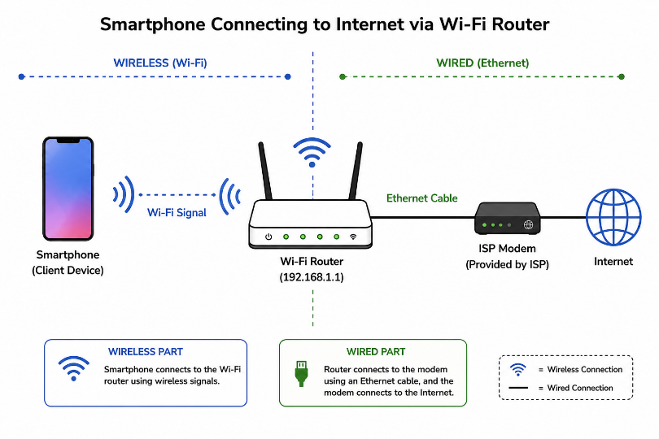
Q3. Scan for available Wi-Fi networks using your laptop or phone, note down the SSID, signal strength, and security type (WPA2, WPA3, etc.) for at least 3 networks, and explain which one you would choose and why. Hint: Consider both signal strength and security when choosing.
Ans.
SSID | Signal Strength | Security
Home_WiFi | ~45 dBm (Strong) | WPA3
JioFiber_5503 | ~58 dBm (Good) | WPA2
DLink_nm550 | ~72 dBm (Weak) | WPA2

- My Choice
- I would choose Home_WiFi because it has strong signal strength and uses WPA3, which provides better security than WPA2.
Q4. Explain in your own words what 'SSID hiding' is in Wi-Fi networks and discuss one advantage and one disadvantage of hiding your Wi-Fi SSID.
Ans. SSID Hiding
- SSID hiding means making a Wi-Fi network name invisible from the normal list of available Wi-Fi networks. Users must enter the network name manually to connect.
Advantage:
- Makes the network less obvious to nearby users.
Disadvantage:
- It does not provide real security because the hidden SSID can still be discovered with network-scanning tools.
- In short: Hiding an SSID can reduce visibility, but it should not be relied on as a security measure.

